**Setting up Application Environment**

**Install IBM Cloud CLI**

|  |  |
| --- | --- |
| Date | 4 November 2022 |
| Team ID | PNT2022TMID47261 |
| Project Name | Plasma Donor Application Using Cloud Computing |
| Maximum Marks |  |

Step 1: Navigate to cloud.ibm.com

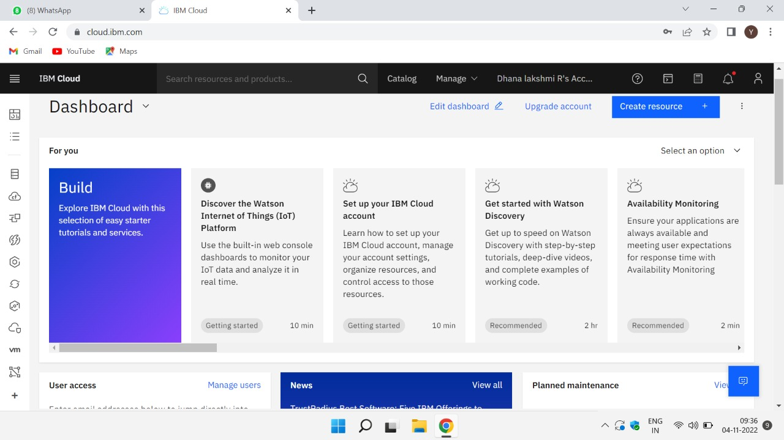

Step 2: Search on Container Registry and give get started and follow the steps to install IBMCloudCLI.

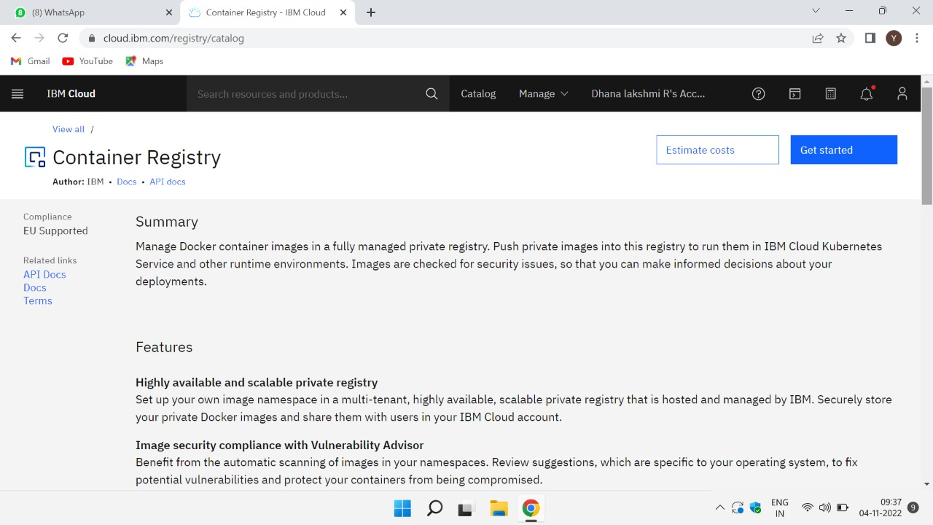

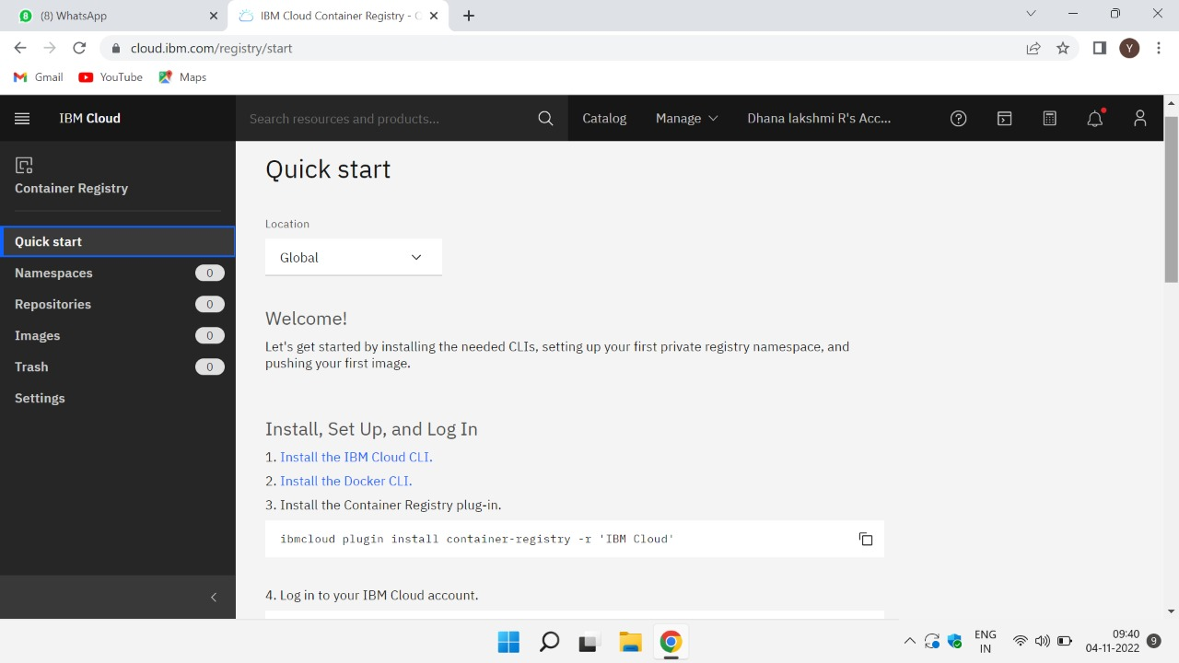

Step 3: Download windows 64-bit installer.

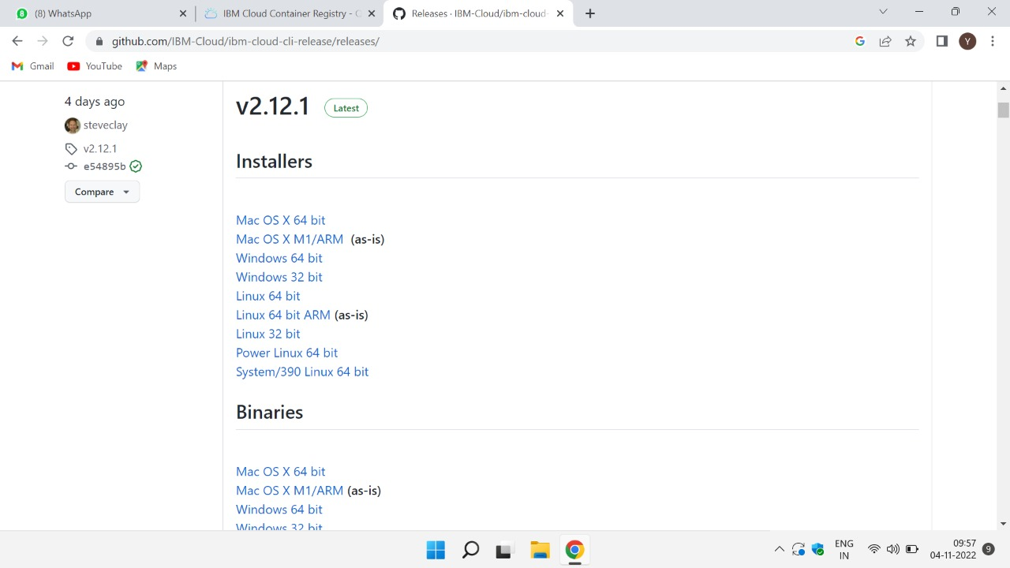

Step 4: Open the downloaded .exe file and run it to install IBM Cloud CLI.

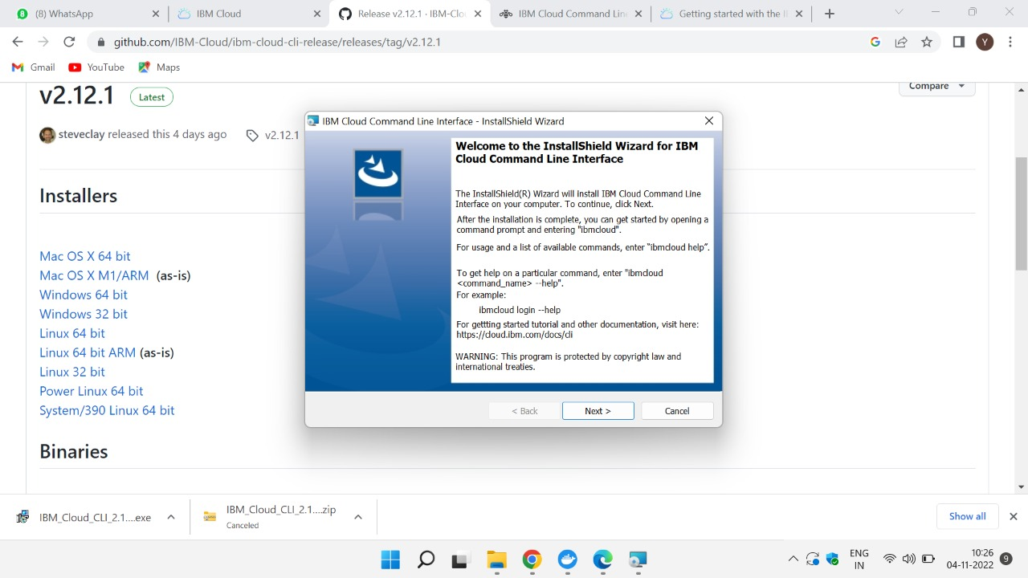

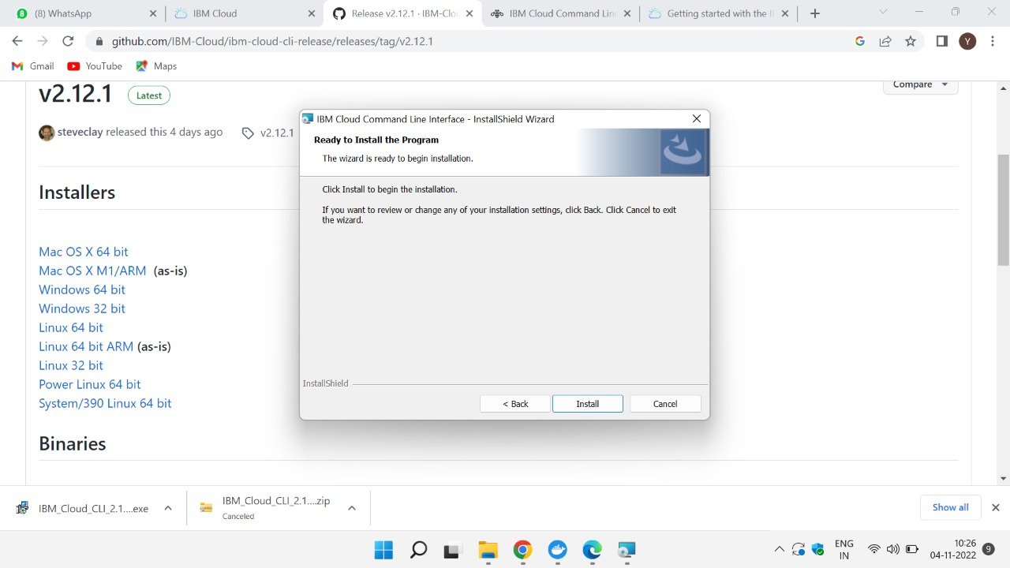

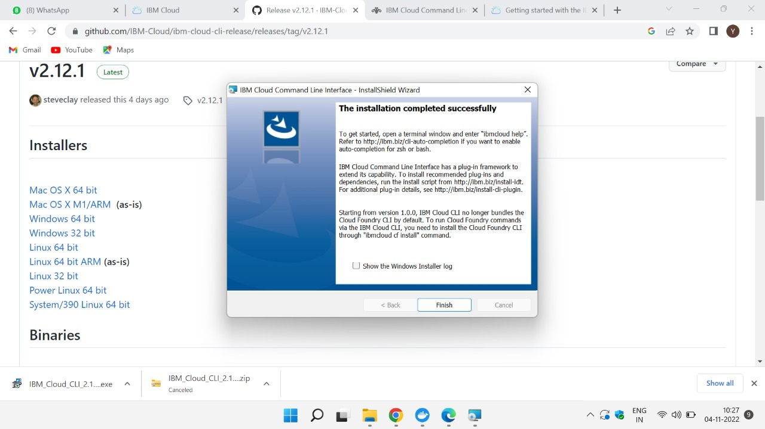

OUTPUT: IBM Cloud CLI is installed successfully.